

FACULTY: Applied and Computer Sciences
DEPARTMENT: Computer Sciences
SUBJECT: Business Analysis 3.2
SUBJECT CODE: AIBUY3A
LECTURER: Mr. Matsela
MODERATOR: Mr. Matsela
YEAR: 2025
ASSESSMENT NAME: | Assessment: Project
ASSESSMENT DATE: | 13 Oct 2025

STUDENT NUMBER | SURNAME AND INITIALS | Student email
221672087 | Mhlongo ZJ | 221672087@edu.vut.ac.za
222385669 | MMM Charles | 222385669@edu.vut.ac.za
223044156 | K Mochaisa | 223044156@edu.vut.ac.za
224221140 | L Sambo | 224221140@edu.vut.ac.za
222059958 | S Sibisi | 222059958@edu.vut.ac.za
221902449 | FN Mkhize | 221902449@edu.vut.ac.za
222618221 | JP Mokgatla | 222618221@edu.vut.ac.za
216076188 | K Mothibe | 216076188@edu.vut.ac.za
222080280 | N Maluleke | 222080280@edu.vut.ac.za

DECLARATION
We, Zwelakhe Jason Mhlongo, Fikile Nonjabulo Mkhize, Jeanett Puseletso Mokgatla, Kamogelo Mothibe, Sthabiso Sibisi, Sambo Locrition, Martial Mukwemba Musinde Charles, Karabo Mochaisa, Nkoka Maluleke
declare that the contents of this project represent our own unaided work, and that the project has not previously been submitted for academic examination towards any qualification. Furthermore, it represents our own opinions and not necessarily those of the Vaal University of Technology.

Signed Date
Signed Date
Signed Date
Signed Date
Signed Date
Signed Date
Signed Date
Signed Date
Signed Date

Table of Contents

Contents
DECLARATION i
Background 1
Problem Definition 1
Business Objectives 2
Poster 4
Success Criteria for Vox Connect AI 5
Tools and Technique 6
Machine learning approach 7
Model 8
Time Series Analysis 9
Solution Techniques 11
Natural Language Processing, Speech Recognition or Speech Synthesis 13
Other Features :( Chat bot/Soft bot) 15

AI-Powered Machine for Symptom Evaluation and Doctor Referral

Background
Vox Connect AI is a smart health kiosk designed to streamline patient intake and triage in clinics and municipal health centres. It uses supervised machine learning and natural language processing (NLP) to interpret symptoms, predict illnesses, recommend specialists. This project aligns with the theme of digital transformation in public health by offering a scalable, intelligent, and locally deployable solution that improves access to care and reduces administrative burden.

Problem Definition
Municipal clinics and community health centres often face overwhelming patient volumes, limited staff capacity, and inefficient intake workflows. Patients endure long queues, struggle to articulate their symptoms clearly, and are frequently misdirected to incorrect departments. These challenges result in delayed diagnoses, increased pressure on healthcare workers, and diminished quality of care.
A key barrier to efficient service delivery is the absence of an intelligent, autonomous triage system that can operate reliably without constant human supervision. Vox Connect AI directly addresses this gap by providing a machine-based solution that captures patient input, interprets symptoms using natural language processing, and recommends appropriate care pathways through supervised machine learning, all from a standalone kiosk.
By solving this problem, Vox Connect enables:
- Faster patient intake and reduced wait times
- More accurate triage and optimized resource allocation
- Scalable deployment across clinics and municipal centres
- Improved data collection for public health planning and analytics

Business Objectives
- We aim to improve access to healthcare by providing autonomous triage machines that guide patients through symptom reporting, illness prediction, and referral especially in under-resourced clinics and community health centres.
- We aim to simplify clinical intake and diagnosis by offering a machine-based solution that reduces staff workload, speeds up patient processing, and improves triage accuracy.
- We aim to build a large user base quickly by deploying Vox Connect AI in public clinics, municipal centres, and mobile health units offering core triage services for free with basic features.
- We aim to partner with healthcare providers and public health organizations to promote their services, integrate referral networks, and support community health initiatives through our platform.
- We aim to expand into broader health and wellness domains, including fitness guidance, mental health support, and chronic condition monitoring creating a unified, accessible health assistant for everyday use.

System Flow
- Patient Input — via touchscreen or voice.
- Symptom Analysis — NLP extracts key symptoms.
- Illness Prediction — ML model predicts likely condition.
- Doctor Referral — Maps condition to correct specialist.
Constraints Faced
- Limited access to real patient data due to privacy laws.
- Hardware limitations (low power devices like Raspberry Pi).
- Language diversity in South African clinics.
- Offline deployment requirements (no cloud dependency).
- Visual accessibility for low-literacy or elderly users.
Risks Taken
- Building a medical prediction system without clinical certification.
- Deploying AI in environments with limited technical support.
- Relying on synthetic data to simulate real-world patient behaviour.
Faults Encountered
- Early NLP models misinterpreted vague or slang inputs.
- Mapping errors due to inconsistent clinic layouts.
- Voice input misfires in noisy environments.
- Overfitting during model training on small datasets.
- UI confusion for first-time users without onboarding.

Poster

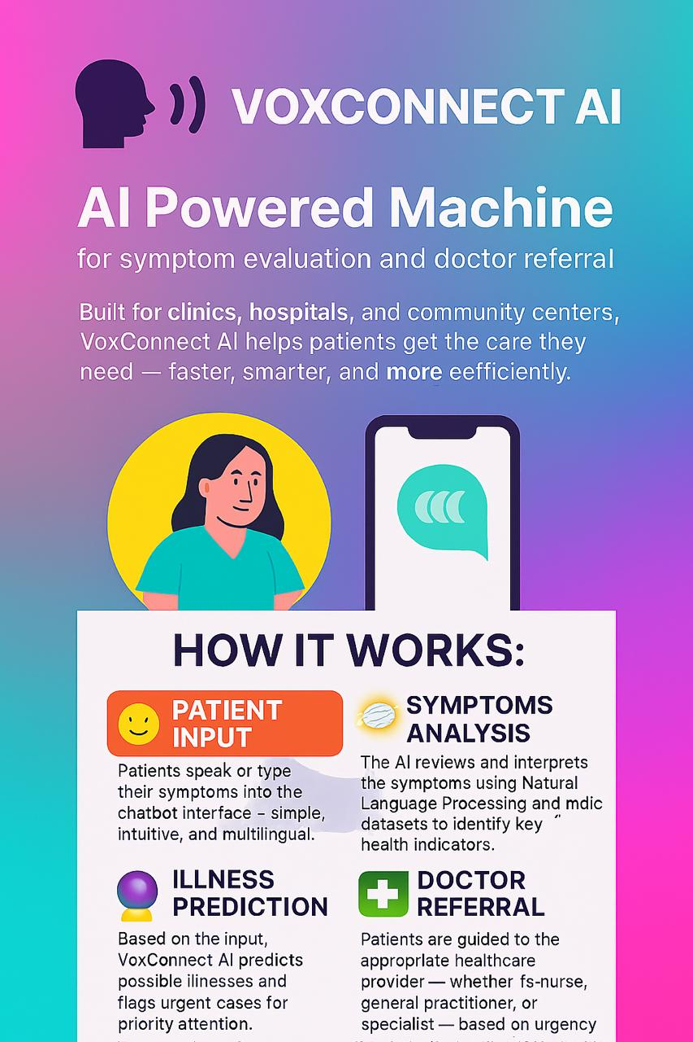

Success Criteria for Vox Connect AI
Functional Accuracy
- The machine correctly identifies symptoms and predicts illness with at least 85% accuracy on test data.
- Referral guidance consistently matches clinic protocols and room assignments.
Usability
- Patients can complete triage in under 3 minutes using voice or touchscreen.
- The interface is accessible to users of different ages, languages, and literacy levels.
- Staff require minimal training to operate or support the machine.
Offline Reliability
- The system runs fully offline on Raspberry Pi or Jetson Nano without internet dependency.
- Voice input and prediction work consistently in low-resource environments.
Multilingual Support
- The machine supports at least three languages (English, isiZulu, Afrikaans) with clear output and input recognition.
- Language switching is intuitive and functional.
Stakeholder Satisfaction
- Clinic staff report improved workflow and reduced intake burden.
- Patients express satisfaction with the triage experience in feedback surveys.
- Community health managers endorse the system for broader rollout.
Scalability
- The system can be deployed in multiple clinics with minimal hardware or software changes.
- Logs and feedback are used to improve future versions and retrain models.
Safety and Ethics
- Patient data is anonymized and securely handled.
- The machine avoids misdiagnosis by routing low-confidence cases to general practitioners.

Tools and Technique
Tools
-Vs code IDE for Application development and AI model development
-Rasa for chatbot and speech recognition framework
- JavaScript for front-end and python for back-end
-GitHub/Git for version control and collaboration
- Kaggle.com for datasets- Disease Symptom Prediction || ML 99%

Techniques Used in Vox Connect AI
Test-Driven Development (TDD)
We apply TDD to ensure the accuracy and reliability of the AI model and system features.
- Unit tests are written before implementing each module
- Model predictions are validated against known cases
- Automated testing helps catch errors early and maintain system stability
Supervised Learning
The AI model is trained using a labelled dataset containing patient symptoms, age, duration, and verified diagnoses.
- Feature engineering is applied to convert text and numeric input into structured vectors
- Models such as Random Forest and Logistic Regression are used for multi-class classification
- Performance is evaluated using accuracy, precision, recall, and F1 score
Prototyping
- Prototypes help gather feedback from clinic staff and patients
- Rapid iteration allows adjustments before full development
- This technique improves usability and stakeholder engagement
SWOT
We use SWOT to assess the strategic position of Vox Connect AI and guide development decisions.
Category | Insights
Strengths | Offline-capable, multilingual, voice-enabled, scalable for low-resource clinics
Weaknesses | Limited initial dataset, hardware constraints, need for staff onboarding
Opportunities | Expansion to mobile clinics, integration with public health dashboards
Threats | Resistance to automation, data privacy concerns, hardware availability

Machine learning approach
Machine learning is a type of artificial intelligence where computers learn from data to make predictions or decisions.
Supervised Machine Learning
- Purpose: Predict illnesses based on labelled symptom data.
- Model Types: Logistic Regression, Decision Tree, Random Forest.
- Training Data: Synthetic + public datasets (Disease Symptom Prediction || ML 99%).
- Features Used: Symptoms, age, duration, severity.
- Output: Diagnosis label (e.g., Flu, Hypertension, Skin Allergy).
- Deployment Format: pkl or onnx model file.
Natural Language Processing (NLP)
- Purpose: Understand patient input in plain language.
- Techniques Used: Tokenization, keyword extraction, symptom mapping.
- Tools: Pandas, spaCy, scikit-learn, custom rule-based filters.
- Languages Supported: English (isiZulu and Afrikaans planned).

Model
The AI model at the heart of Vox Connect AI helps patients receive tailored triage guidance based on their symptoms, location, and health context. Imagine an assistant that understands your condition, knows where you are, and helps you get the care you need quickly, accurately, and without human supervision. That’s the vision behind Vox Connect empowering people from all walks of life to access better healthcare.
How It Works
The system learns about each patient from the information they provide. It considers:
- Reported symptoms (e.g. fever, cough, fatigue, nausea)
- Health context (e.g. age, symptom duration, chronic conditions)
- Current location (e.g. clinic, mobile unit, or remote area)
Based on this input, the AI predicts the most likely illness and refers the patient to the appropriate department. If the patient is in a clinic, it guides them to the correct nurse or doctor. If they’re in a mobile unit or community centre, it provides clear instructions on what to do next.
Whether someone is at home, in a rural clinic, or visiting a municipal health centre, Vox Connect AI adapts to their environment and needs. It even works offline, ensuring access in low-resource settings.
Performance Evaluation
To ensure the AI remains helpful and accurate, we continuously monitor its performance using three key metrics:
- Accuracy How correctly the model identifies the illness based on symptoms and context. For example, if a patient reports a peanut allergy, the system should never suggest a treatment or referral that involves exposure to peanuts.
- Precision How closely the AI matches the patient’s exact needs. If someone requires lower cost care, the system should avoid suggesting premium services or specialists unless absolutely necessary.
Learning from Trends Over Time
What makes Vox Connect AI truly powerful is its ability to learn from patterns across weeks, months, and seasons. For example:
- If patients in a region tend to report flu-like symptoms during winter, the system adjusts its predictions accordingly.
- If certain clinics experience higher traffic on Mondays, the AI adapts its referral logic to reduce bottlenecks.
- It also learns from individual usage recognizing if a patient frequently reports recurring symptoms and adjusting its guidance.
Always Improving
The more Vox Connect AI interacts with patients, the smarter it becomes. Every interaction helps us collect feedback, retrain the model, and improve future recommendations. We regularly update the system to ensure it performs at its best just like tuning a machine to keep it running smoothly.

Time Series Analysis
Time series analysis in Vox Connect AI focuses on data collected over time to uncover patterns in patient interactions, symptom trends, and system performance. These insights help clinics optimize resources, improve triage accuracy, and adapt to seasonal health demands.
1. Patient Intake Over Time
Input:
- The database includes timestamped records of patient triage sessions
- Each record contains symptoms reported, age, duration of illness, and referral outcome
- Additional metadata includes time of day, day of the week, and whether the visit occurred on a weekend or public holiday
Process:
- Sort and categorize triage sessions by time (hourly, daily, weekly, monthly)
- Group data by symptom type and referral department
- Analyse peak hours and common conditions during different time blocks
Output:
- A dashboard showing patient volume by time of day and day of week
- Insights to help clinics allocate staff and resources more effectively
- Alerts for unusual spikes in specific symptoms or conditions
2. Symptom and Illness Trends
Input:
- Historical triage data with diagnosis labels, symptom combinations, and seasonal tags (e.g. winter flu, summer dehydration)
- Includes anonymized patient demographics and referral outcomes
Process:
- Organize data by season and diagnosis
- Track frequency of specific symptoms and illnesses over time
- Compare seasonal trends to identify recurring health patterns
Output:
- Predictive insights for upcoming health trends
- Seasonal adjustment of triage logic and referral mapping
- Support for public health planning and early warning systems
3. Triage Performance Monitoring
Input:
- Logs of system response time, referral accuracy, and patient feedback
- External factors such as clinic traffic, staff availability, and local health alerts
Process:
- Analyse triage duration and referral precision by time of day and clinic load
- Compare performance against external conditions (e.g. flu season, staff shortages)
- Identify bottlenecks or inconsistencies in prediction accuracy
Output:
- Performance reports with actionable suggestions for system tuning
- Alerts for low-confidence predictions or referral mismatches
- Continuous improvement of the AI model through retraining and feedback

Solution Techniques
Vox Connect AI uses a combination of intelligent data processing, machine learning, and voice-enabled interaction to deliver accurate, personalized triage guidance in clinics and community health centres. Below are the approved techniques that support its functionality and continuous improvement.
1. Data Gathering and Processing
- Collect and process data from patient symptom logs, clinical guidelines, referral records, and public health databases
- Use structured and unstructured data to train the AI model, including age, symptom duration, and diagnosis history
- Integrate multilingual symptom descriptions and voice input for inclusive access
2. Natural Language Processing (NLP)
Implementation: NLP is used to understand and process patient queries and symptom descriptions in natural language.
Functionality:
- Recognizes phrases like “I’ve had a fever for three days” or “I feel dizzy and nauseous”
- Extracts key symptoms, duration, and context from spoken or typed input
- Supports multiple languages including English, isiZulu, and Afrikaans
Relevance: NLP makes Vox Connect AI intuitive and user-friendly, allowing patients to interact with the system as they would with a nurse or receptionist.
Achievability: Highly achievable using existing NLP libraries and APIs such as spaCy, NLTK, or cloud-based tools like Google’s Natural Language API.
3. Speech Recognition
Implementation: Speech recognition converts spoken input into text for analysis by the NLP system.
Functionality:
- Enables hands-free interaction for patients
- Supports voice commands and symptom reporting
- Enhances accessibility for users with limited literacy or mobility
4. Image Recognition (Optional Extension)
- Recognize visual cues such as skin rashes, swelling, or visible symptoms using camera input
- Assist in identifying medication labels or clinic signage
- Can be integrated with mobile or kiosk-based deployments
5. Improving Model Accuracy
- Integrate clinical guidelines, public health alerts, and seasonal illness trends to keep the model current
- Use anonymized patient feedback and referral outcomes to retrain and refine predictions
- Embed systems that continuously learn from new data and adapt to changing health patterns

Natural Language Processing, Speech Recognition or Speech Synthesis
Natural Language Processing (NLP)
Implementation: NLP is used to understand and process patient queries and symptom descriptions in natural language.
Functionality:
- Interprets input such as “I’ve had a fever for three days” or “I feel dizzy and nauseous”
- Extracts key symptoms, duration, and health context from spoken or typed input
- Supports multilingual interaction (e.g. English, isiZulu, Afrikaans)
Relevance: NLP makes Vox Connect AI more user-friendly and intuitive, allowing patients to engage with the system as they would with a nurse or receptionist.
Achievability: Highly achievable using existing NLP libraries and APIs such as spaCy, NLTK, TensorFlow, or cloud-based tools like Google’s Natural Language API.
Speech Recognition
Implementation: Speech recognition converts spoken input into text, which is then analysed by the NLP system.
Functionality:
- Enables hands-free interaction for patients
- Supports voice-based symptom reporting and triage initiation
- Improves accessibility for users with limited literacy or mobility
Relevance: Enhances the user experience, especially in busy clinics or for patients who may struggle with typing or reading.
Achievability: Very achievable using established APIs such as Google’s Speech-to-Text or offline engines like Vosk.
Speech Synthesis
Implementation: Speech synthesis translates system responses into spoken language.
Functionality:
- Reads out triage results, instructions, or room assignments
- Supports visually impaired users or those with reading difficulties
- Improves clarity and engagement in noisy or crowded environments
Relevance: Makes Vox Connect AI more inclusive and practical in real-world clinic settings.
Achievability: Highly achievable using text-to-speech APIs such as Google’s Text-to-Speech or offline alternatives like e Speak.
Integration and Workflow
- User speaks a symptom or health concern
- Speech Recognition converts it to text
- NLP processes the text to understand intent and extract relevant medical information
- Prediction Engine uses this data to generate a diagnosis and referral
- Speech Synthesis reads the result aloud to the patient
Relevance to the Theme and Proposed Solution
These AI technologies make Vox Connect AI more interactive and personalized, aligning with the theme of advanced healthcare automation. They address the core problem by making triage easier, faster, and more accessible especially for patients with language barriers, disabilities, or limited literacy.
They also help users understand their symptoms, receive accurate guidance, and make informed decisions in a seamless, conversational way.
Achievability
The integration of NLP, Speech Recognition, and Speech Synthesis into Vox Connect AI is highly achievable:
- Numerous well-established APIs and libraries exist for each technology
- Cloud-based solutions reduce the need for on-device processing power
- Custom training may be needed to fine-tune models for healthcare-specific language
- An AI Conversation Manager module can coordinate the flow between user input, prediction, and response

Other Features :( Chat bot/Soft bot)
Vox Connect AI includes a chatbot interface that simulates human conversation using Natural Language Processing (NLP) and machine learning. This chatbot is designed to assist patients in reporting symptoms, receiving triage guidance, and navigating clinic services all through a conversational, voice-enabled experience.
What the Chatbot Can Do
- Understand patient input by analysing spoken or typed symptom descriptions to identify health concerns, duration, and urgency.
- Provide personalized triage guidance based on the patient’s symptoms, age, and location.
- Deliver health information by sharing basic details about common illnesses, next steps, and clinic procedures in a clear and accessible format.
Data Preparation and Modelling
- Data collection involves using anonymized triage records, symptom logs, and public health datasets to train the AI model.
- Data cleaning ensures consistency and accuracy by removing duplicates, correcting formats, and validating entries.
- Clustering techniques such as K-Means Clustering are used to group patients with similar symptom patterns, age ranges, or referral outcomes.
- Content-based filtering uses keywords from patient input to match symptoms with known conditions and referral pathways.
Key Tools and Technologies
- Natural Language Processing (NLP) is used to understand patient input and generate human-like responses.
- Machine Learning (ML) enables the system to learn from patient interactions and improve triage accuracy over time.
- Python is the core programming language used for AI, NLP, and system integration.
- Dialog flow or Rasa powers the conversational interface and manages dialogue flow.
- K-Means Clustering helps group patients based on symptom similarity and health context.
- Content-based filtering suggests triage outcomes based on similarity to previous cases.
By combining these techniques, the Vox Connect chatbot becomes a powerful tool for:
- Reducing wait times and intake bottlenecks
- Supporting multilingual and voice-based triage
- Making healthcare more accessible, especially in under-resourced clinics
- Continuously improving through feedback and usage patterns

